
SCISSOR LIFT TABLE - CHECK LIST
Sr. No | Description | Unit | Remark
1 | Type - Floor Mounted / Pit Mounted / Mobile |  | Floor Mounted
2 | Capacity – Kgs | Kg | 2.0 MT
3 | Platform Size - L X W (mm) | mm | 1800 X 1500
4 | Lift height (Excluding close height) | mm | 2.0 Meters
5 | Closed Height | mm | Std
6 | Total height | mm | ----
5 | Available Space (L X W) | mm | ----
6 | No of lip required | mm | 2 nos
7 | Lip (Length X Width) |  | 400 mm
8 | Lip Operation (Manual / Hydraulic) |  | Manual
9 | Entry & exit side (please specify in detail) |  | Width wise (one side entry and other side Exit)
10 | Load type (with pallet / without pallet) |  | With Pallet
11 | Type of platform (chequered plate / plain sheet) any other material please specify |  | Plain
12 | Color (NIHVA STD = GOLDEN YELLOW) |  | NIHVA STD.
13 | Railing require or not (if require pls specify dimension) |  | 2 side Required. 900 mm H
14 | Other requirement - please specify in details |  | ----
15 | Operation through (Manual / AC OPERATED) Please specify the MHE details |  | AC Operated
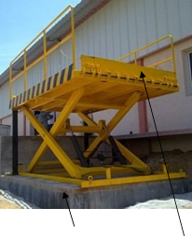

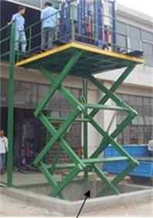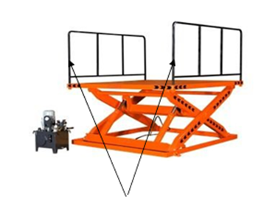
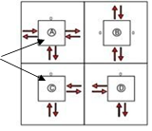
Floor Mounted Scissor Lift Pit Mounted Scissor Lift Detachable Railing - 2 Side Lip - 2 Side (Loading / Unloading)

Entry / Exit Option

